

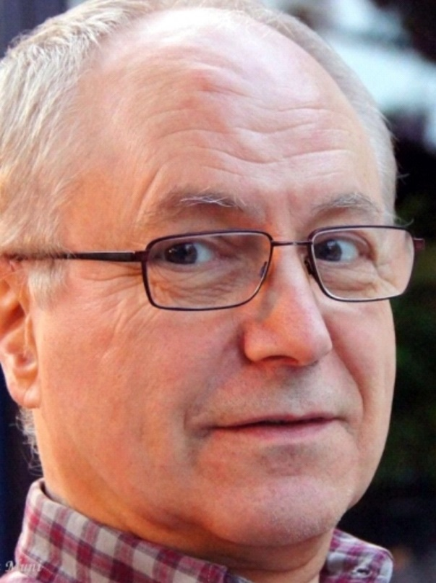

A Tribute to

Herman Seymus

The Preface written by Herman for the booklet marking the EUY’s 40th anniversary
The first International Yoga Congress of the EUY took place from the 2nd to the 9th September in 1973. As the current general secretary of the EUY, I feel fortunate to write the introduction of this booklet to celebrate the 40th International Yoga Congress, still taking place in Zinal.
This means that the congress has reached its midlife. In a man’s life this means a period of turmoil and reorientation, for better or worse. It is my impression that we are also at a turning point where either or both may happen. Gérard Blitz, the founding father of the Club Méditerranée, was the inspiration and the driving force behind this annual gathering. He was born in 1912, exactly the same year as my own father. And he was also a Belgian citizen, coming from the same region as your servant, the Antwerp area.
After the congress, André Van Lysebeth, also a Belgian, and a close friend of Gérard, published his impressions and opinion in the article: ‘Premièr congrès Zinal UEY’ published in his bimonthly Journal ‘Yoga’. With 350 participants, and T.K.V. Desikachar as one of the honorary guests, this first congress was a real success. By the way, Shri T.K.V. Desikachar, who was for 30 years a student of his famous father T. Krishnamacharya, celebrates his 75th birthday this year. You may consider all this a coincidence or synchronicity. It was definitely not a conscious choice of mine to accept the function of Secretary General ad interim in August 2012, here in Zinal, and find myself writing this introduction for this 40 year anniversary of the International Yoga Congress.
The International Yoga Congress in Zinal was originally established to test the ‘raison d’être’ of the EUY and has now become a real-life demonstration of what the European Union of Yoga should be: a meeting point where knowledge and experiences are being shared in an inspirational environment. In 1990, when Gérard left his body, the congress was in a crisis situation, the Club Med building was no longer available to house the congress, the leaflets were already printed and distributed and participants were enrolling. Another Belgian pioneer, Roland Fauconnier together with Philippe de Fallois, who believed it was possible to organise the congress independent of the Club Med facilities, put all their time and energy behind the belief that it was possible to rescue the congress of 1990. The EUY remained sceptical. But against all odds and with the help of Jacqueline Lacour and others, they succeeded! They developed another option, which is still being used. Their trust and belief moved mountains and made possible what seemingly appeared impossible. If we can muster the same unshakeable confidence and belief, the following 40 years of the international yoga congress will be a reality.
Herman Seymus
Secretary General et delegate of the ABEPY, Belgium

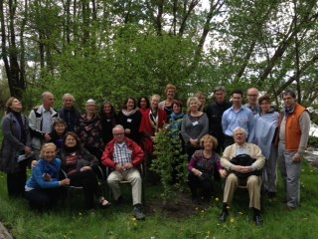
I met Herman Seymus (commonly known as Suman to his students and within his Federation) at my first EUY General Assembly in Utrecht many years ago. As a complete novice, in my eyes Herman Seymus, Gert-Jan Overdijkink, Jules-Marc Baudel, Geza Timcak and Mario Vasilescu were the elders of the EUY and protectors of the organisation.
In 2009 I volunteered to be on the Zinal organising team with Herman and Sergio and again in 2010 with Herman and Geza. Herman always treated my enthusiasm with respect, and patiently and willing guided me in the process of choosing teachers, organising the weekly programme, assigning rooms – everything that organising the Zinal Congress entailed. For this (and so much more) I am forever grateful.
Herman held the EUY in high regard and served the organisation with respect and humility for so many years; firstly as a delegate for his Federation, the YFN, then as the Education Team Coordinator and as General Secretary ad interim during the EUY reorganisation process.
Herman was a role model to me and encouraged me at every turn, particularly when I was considering applying for the post of EUY President. He was always available to answer questions and queries, to offer aid in difficult situations – to listen, to hear and to offer his wisdom and support.
But above all Herman had a quiet demeanour, which exuded deep wisdom that came from his dedicated daily practice.
May Herman’s integrity and love of the EUY remain an example to us all and may his soul rest in peace.
In gratitude for walking beside him for a few steps on this journey.
Gabi Gillessen

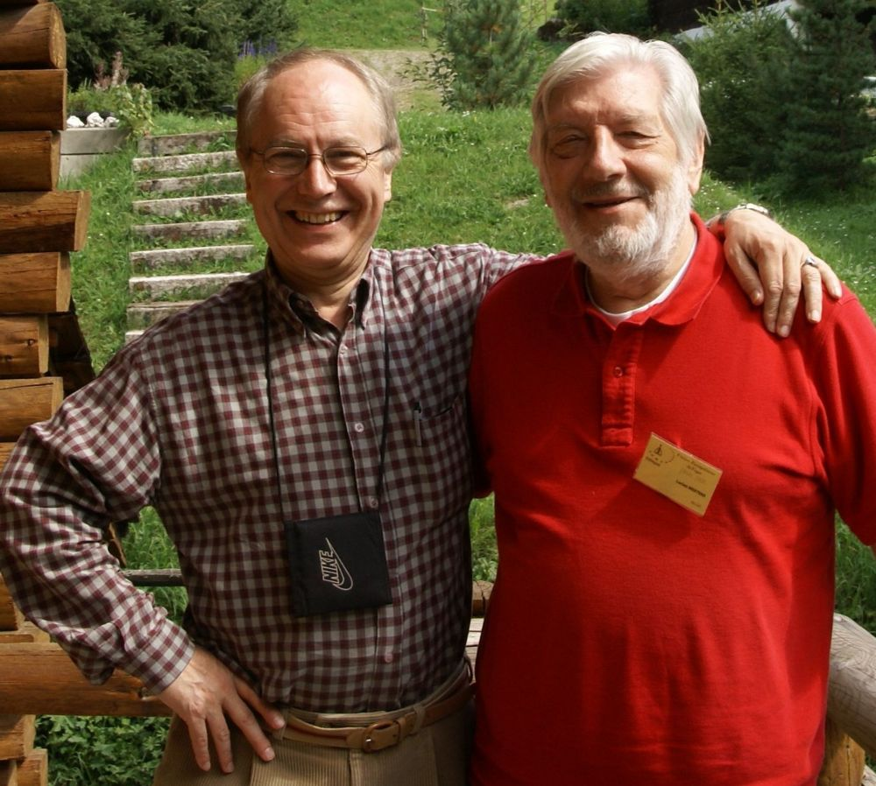
I knew Suman for 53 years and worked closely with him. He was my right arm in our Yoga teachings and a very welcome friend in my life. His untimely passing weighs heavily on me. On January 15, he suffered a brain haemorrhage, which was not entirely unexpected, since in 2019 he had two severe TIAs in quick succession, which was a serious warning.
From early childhood he was a seeker and an inquirer, not satisfied with the ready-made answers and certainties presented to him. He was no follower and was destined for more.
When we started to offer our Yoga classes to a wide audience in 1968, we did not want to simply teach some practices and techniques superficially. We set out with the intention of hopefully guiding one white raven in a hundred disciples on the path of spiritual experience. That first year, I visited every interested person at home for an interview before enrolling them, looking for that possible 1 in 100. I visited Suman at home and had a conversation with him from 7 pm until midnight. I immediately realised that he might be one of the white ravens. He went on to become one of our foremost teachers, a task he performed with dedication and commitment right up until his death.
Suman Jī was an introverted man, gentle and sensitive, with a non-violent disposition and he acted from inner goodness. He was a Yogin. Astrologically he was a lion, which allowed this silent man to be seen and heard without any effort. He was a perfectionist and at the same time he was sometimes naive and gullible.
Suman is no longer… at least not in physical, perceptible form among us anymore. But for those who loved him, he is buried in their hearts, the only true and precious burial place. I’m glad Suman was in my life and for those who loved him the pain will be with us for a long time to come. But it will wear off and disappear and the memory of a good person will remain.
Atma Muni (alias Lucien Mertens)

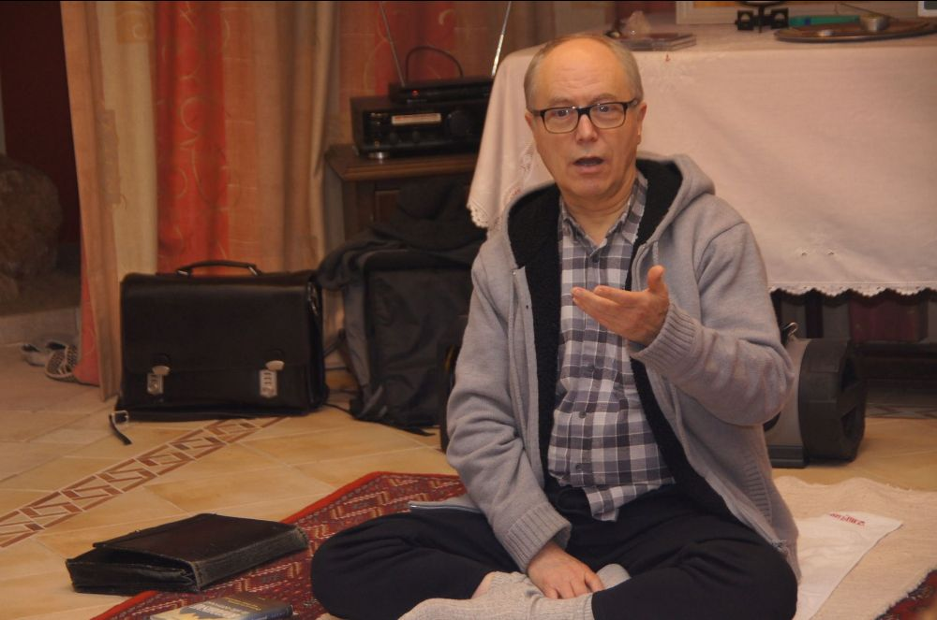
Herman Seymus, a charismatic personality, member of the EUY as delegate of the ABEPY since 2008, head of the pedagogic commission later called Meeting Team and General Secretary from 2012 to 2014.
I remember Herman. I remember Herman Seymus. I remember the Flemish delegate of the Yoga Federatie van de Nederlandstaligen in België, who preferred to speak English rather than French, as he confided one day during a private conversation. He was a paternal colleague, convinced that the capacity to practise Yoga could resolve the most important problems of daily life, even of the whole world.
For this reason he constantly committed himself to European Yoga in order to share his vision and mission with the European Community of Yoga that is the EUY. For him yogic behaviour between Yoga colleagues and EUY delegates was part of his way of practising Yoga. After Claire Bornstain stepped down as General Secretary, the EUY faced a deep crisis and in spite of his age he agreed to become ‘ad interim’ General Secretary and started literally to move the car out of the mud as we say in German. So I was lucky enough to work with him, along with Miriam Brady from the IYA, Geza Timcak from the SAJ and Daniel Stephany from the Fédération belge d’Hébertisme et de Yoga, on creating the new structure ‘without re-inventing the wheel’, like Herman used to say. Eveline Waas Bidaux from Yoga Schweiz also supported this process, not forgetting Gabi Gillessen from the IYA, Roland Haag from the Schweizer Yogaverband, and Gert-Jan Overdijkink and Marjo Havinga from the Stichting Yoga Vedanta who managed to bring the Zinal Congress through this moment of crisis. Herman used to say: ‘If you really want to create something new, you need to start from scratch!’
He didn’t like hierarchies. In his opinion they were even destructive. So we all worked as peers and felt really good together. This period was hard and made us all aware of our personal limits, but due to Herman’s charismatic personality we were all keen to give of our best. And he also had the capacity to convince all the other EUY delegates, even the ones who were sceptical about the positive outcome of the reorganisation process. By the end we were all sailing in the same boat!
This interim period lasted nearly two years, from August 2012 until August 2014. And wasn’t really clear if the EUY would survive as a unified organisation. The waves got dangerously high. There was fear of creating something new and totally unknown. Support came from the Flemish organisation ‘Nexus’ and its coaches Steven De Cauwer and Henk Bruning, who guided us through this process. And here also Herman defended accurately this unusual form of coaching, although it was a heavy financial investment for the EUY.
He defended the goals he wanted to reach but he was also able to admit errors and he was ready to assume responsibility for them when needed. And he liked to recount how he had first encountered Yoga at the young age of seventeen. He wanted to know what the nature of Yoga was and asked a teacher in Belgium to help him understand. This teacher gave him the exercise of practising śavāsana. Herman was told to come back only when he felt something special about it. So, he practised every day for a quarter of an hour, but at first nothing happened, so he went to the teacher and told him that. The teacher said there was no problem in feeling nothing, but he should continue to practise. After quite a long period, one day Herman felt like he was nearly leaving the ground with his whole body and he felt like he was being carried by the earth. He went back to his teacher and told him so. At this point the teacher said to him: ‘Now you know the nature of Yoga. We can take the next step!’
This simplicity and clarity were Herman’s special gifts and I will remember him like this forever. I am grateful from the bottom of my heart to have had the chance to know him!
Susanne Bohrmann-Fortuzzi, delegate of the BDY/Germany

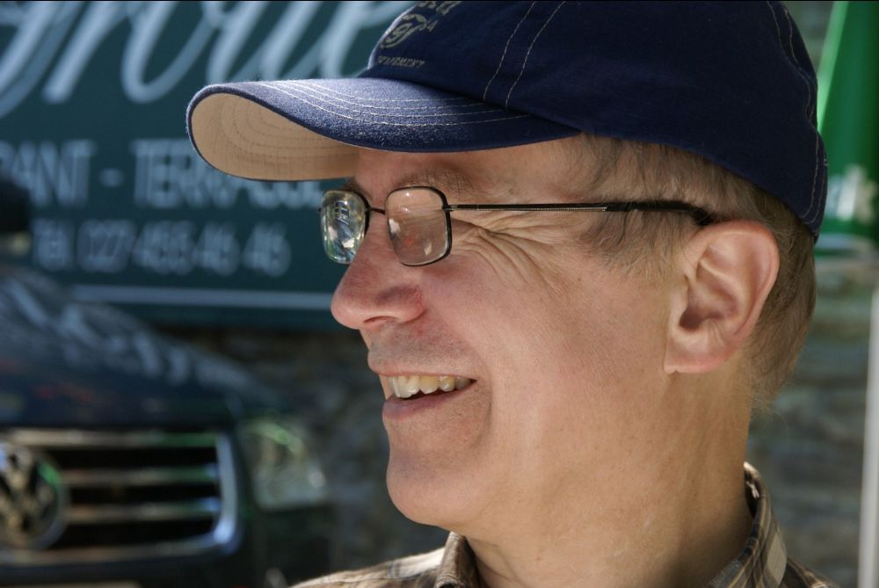
Herman’s EUY: The vision of a yogic organisation as the embodiment of a consensus-based trusting community
My first EUY meeting was the General Assembly during the EUY Congress in beautiful Zinal in August 2012. My federation told me about the extraordinary atmosphere and legacy regarding the teaching and practising of yoga in Western Europe, so I packed some clothes and my yoga mat and travelled up the mountains.
Since I didn’t know where the meeting was going to take place, I was told to go to the EUY Zinal office. On my way to the place it started to snow. Nobody had told me that it could get that cold in summer in the mountains. At the office I was told that the General Assembly took place in a tent on a parking lot just a few metres ahead. In a tent? While it was snowing and freezing cold? Unusual and extraordinary, indeed. On reaching the tent, I saw the delegates sat on blankets, wrapped in thick jackets, but contrary to the outside, inside the tent, the atmosphere was concentrated and energising. The EUY was in the middle of its re-organisation process, as Susanne has described in this newsletter and Herman who had been voted ‘president ad interim’ was at the heart of this transformative process.
Usually calm and focused during most of the meetings, Herman could get passionate when the assembly was in heated discussion about a clear vision and mission for the EUY and was determined that an organisation who wants to transmit and cherish the essence of yoga also has to live and implement it in its own structures and everyday business.
I still hear his soft but determined voice, advocating that such an organisation should be based on a sociocratic dynamic governance model – a form of organisation that strives to create psychologically safe and trusting environments to come to consensual and sustainable agreements. Living in such an environment supports the yogic path, enabling the discovery of oneself in depth, through self-knowledge for every human being. With his presence, Herman was essential to authentically moulding the path for developing such an organisation.
What a treasure to have been part of this process, what a treasure to have known Herman!
In the following years, all the delegates and team members worked on bringing this vision into reality, with all its failures and successes, but especially after the experience of the Corona pandemic as a vision and possibility that is needed more than ever.
Nora Gresch, EUY board member 2014-2020, Yoga Austria-BYO

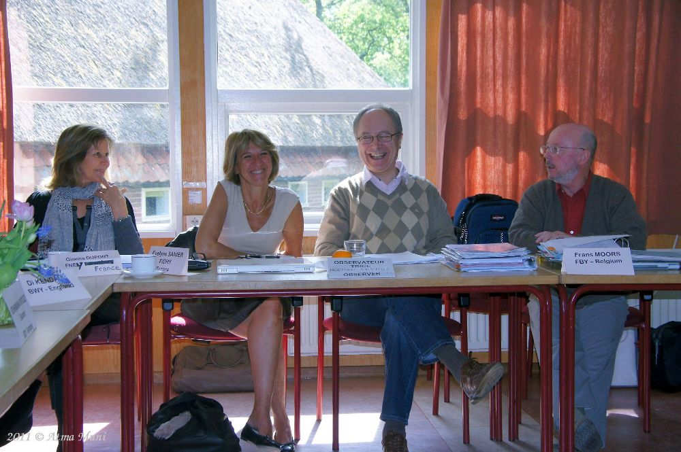
First of all, I’d like to speak directly to Herman to thank him warmly for his commitment to the path of yoga and to yoga in general.
When we met during the transition years leading up to the EUY’s 40th anniversary, he made a point of encouraging us to define a shared vision that wasn’t uniform, and was enriched by each person’s views. He thus brought us together, not around the social project that yoga can offer, but at the very heart of Yoga itself. You can still read his words in the preface he wrote for the booklet produced for the EUY’s 40th anniversary.
Second, I’d like to speak directly to his family, his friends and all his students, supporting them with my deepest tenderness and compassion in the sense of absence that they are now coming to terms with. Time enables us to experience the emptiness that is made obvious by the absence of a beloved person. That is how the link between heart and Heart can become clear and dispel sadness, leaving a sense of contentment at having known him well. That is the path I’m choosing as the announcement of Herman Seymus’s death passes through me.

On the departure of Suman
by Communication Team | Aug 2, 2021 | Uncategorised

(August 10, 1943 – June 9, 2021)

We are transient… Everything and everyone lives dies, each in his own time.

On June 09, 2021 it was the time for Suman Jī…

GENESIS OF A YOGA LIFE

From early childhood he was a seeker and an enquirer, not satisfied with the ready-made answers and certainties presented to him. He was no follower and was destined for more.

When we (the Mertens brothers – the Muni brothers) started to offer our Yoga classes to a wide audience in 1968, we did not want to simply teach some practices and techniques (āsana and prāṇāyāma) superficially. We set out with the intention of hopefully guiding one white raven in a hundred disciples on the path of spiritual experience. That first year, I visited every interested person at home for an interview before enrolling them, looking for that possible 1 in 100. I visited Suman at home and had a conversation from 7 pm until midnight with him. I immediately realised that he might be one of the white ravens. He was no. 14 of a list of thousands after him. Since then I have guided and stimulated Suman in his growth process over the years.

He was given the name of Suman, meaning ‘flower’ or ‘blossom’ or possibly ‘charming, friendly’ in 1973 by Mahārāj Jī (Swāmī Yogeswarānanda) at his initiation into Guru Dikṣā. He became one of our foremost teachers, a task he performed with dedication and commitment right up until his death.

In 1976, along with some others, including Rāma and Sītā, on our recommendation he was awarded the diploma of Hatha and Rājā Yogācārya from Mahārāj Jī. In that same year he started as a teacher at our Yoga Academy (Shri Yogeshwarananda Yoga Mahavidyalaya vzw), where he gradually developed into a very beloved and inspiring, supportive force.

SUMAN AS A HUMAN BEING

Suman Jī was an introverted man, gentle and sensitive, with a non-violent disposition and he acted from inner goodness. He was a Yogin. Astrologically he was a lion, which allowed this silent man to be seen and heard without any effort. He was a perfectionist and at the same time he was sometimes naive and gullible…

In the 1980s and 1990s he sometimes got carried away with the suggestive manipulation of some swāmīs, who later turned out to only be after power and money (not all is gold that glitters and caution is advised). I warned him about this, leaving him free to come to his own understanding. At one point he was completely under the control of a manipulative female swāmī and I told him he had more Yoga in his little finger than she had in her whole being…Her influence wreaked havoc on his pure mind and it took him years to recover. Among other things, she performed an exorcism on two of our students, who subsequently needed psychological and psychiatric help, and one of them later committed suicide. He eventually came out of it stronger and it gave him a stable maturity for the rest of his life.

I knew Suman for 53 years and worked closely with him. He was my right arm in our Yoga teachings and a very welcome friend in my life. His untimely passing weighs heavily on me.

On January 15, he suffered a brain haemorrhage. From then on his agony of hospitals, rehabilitation centres and a residential care centre began. No sinecure in Corona times! Not even for his wife Pratibhā and son Jehudi. It was not entirely unexpected either, since in 2019, he had two severe TIAs in quick succession, which was a serious warning…

SUMAN IN THE YOGA FEDERATION

During his working life as a chemical engineer he had a busy and demanding life and only after his early retirement did he take on other tasks. He effectively became treasurer of our associations and he was involved in the evolving legislation on non-profit organisations. Later he became vice-chairman of our Yoga Academy in Mechelen. He also became a member of the governing board of the Yoga Federation after 2000.

After the resignation of Roeland Fauconnier as chairman, Suman was elected. He accepted the position on the condition that he delegate tasks and that the Yoga Federation become ‘Yoga’ again…And he did that perfectly. After he took office, the numbers of those present at our weekends went up spectacularly, increasing threefold. He restructured the organisation into specialised groups with specific tasks and responsibilities, steering the ship in safe and calm waters for over 15 years…He was a wise and calm moderator, loved and cherished by all.

SUMAN IN THE EUROPEAN YOGA UNION

As Chairman of the Yoga Federation, he also served on the board of directors of the EUY. Because of his qualities, he was quickly approached for all kinds of other positions. For example, he was a member of the diploma committee, he was Chairman of the Education Committee for years and he was a bit tricked into becoming Secretary General, which he didn’t really want to do. In the name EUY the U(nion) and Y(oga) were missing…He also successfully accomplished this task, even though he was fighting a losing battle. I warned him not to give in to all kinds of pressure groups and to impose Yoga, to which he replied he was using me as a secret weapon…

GOODBYE SUMAN JI

Suman is no longer… at least not in physical, perceptible form among us anymore. But for those who loved him, he is buried in their hearts, the only true and precious burial place.

‘Never was there a time when I was not and you were not of these rulers over men; nor shall any of us hereafter ever cease to be.’ Bhagavad Gita, Chap. 2, verse 12

I’m glad Suman was in my life and for those who loved him the pain will be with us for a long time to come. But the pain will wear off and disappear and the memory of a good person will remain…

Atma Muni / Lucien Mertens

